# RAEF Read Me —Installation and Operation Guide for RAEF —Version 2.6.19

**Contents**

Package Contents 2

Important Notes 3

Download R 4

Install the R Console 4

Unzip the RAEF Package 5

Install Required R Package Files to Run RAEF 5

Inputs to RAEF 5

Start RAEF (startup dialog/ central base GUI for the RAEF package) 7

Batch Run Option Vs. GUI Option 8

Launch RAEF Using the GUI Option (Without Pre-Set Parameters) 8

Fill out the RAEF GUI Dialog 9

Input Files 9

Deposit Information 10

Mine and Mill Information 12

Days of Operation 15

Waste Management 15

Confirm Data 16

Change Default Values 17

Run and Download RAEF Output 19

Use the Pre-Set Parameters option 22

Run Empirical Mode 24

RAEF Tutorial Exercises 26

Porphyry Copper Deposits Exercise 1A: Regular Non-Missing Grade Values Run 26

Porphyry Copper Deposits Exercise 1B: Empirical Missing Grade Values Run 29

Porphyry Copper Deposits Exercise 1C: Using a Pre-Set Parameters File 31

Conduit Deposits Exercise 2A: Regular Non-Missing Grade Values Run 32

Conduit Deposits Exercise 2B: Empirical Missing Grade Values Run 35

References Cited 36

## Package Contents

The RAEF package includes the following files:

1. *RunRAEF.R*—The R script used to launch and run the RAEF graphical user interface (GUI).
2. *InstallPackages.R*—The R script used to automatically install the R packages required to run RAEF.
3. *BatchFileTemplate.xslx* – A template to help format the pre-set parameters input file
4. *RAEFVariableGlossary.xlsx* – A glossary of the data variables in the RAEF output.
5. AuxFiles folder- A folder containing important auxiliary files that support the running of RAEF. These includes the internal process R scripts (RScripts subfolder), key internal resource calculations tables (including the internal resource metallurgical recovery rates table and the commodity values tables - ValueTabs subfolder), and the GUI banner image (Images subfolder)
6. MapMark4Results folder- A folder of sample MapMark4GUI run results using the MapMark4 R package that can be used to test and learn RAEF processes. The file, *RunID_05_SIM_EF.csv*, can be inputted as the Grade-Tonnage Model (GTM) into the RAEF run.
7. TUTORIAL_Pkg folder– A folder that includes a set of tutorial exercises to learn the RAEF program process and provides examples of input and output files.
8. *RAEFReadMe.docx*—A step by step guide for RAEF installation and operation.
9. *UserGuide_RAEF.pdf*—The RAEF user’s guide.

## Important Notes

* R Version:
* The R script for RAEF and the steps described below have been verified to run in versions 3.4 and 3.5.1 of the 32- and 64-bit R console.
* While selecting the package in the R script, make sure the package general level folder is selected. The folder is titled “Package”. This folder has the subfolder of “Auxfiles”.
* Previous packages:
* If you previously installed and ran the package “gWidetsRGtk2,” you will have to remove the package by typing the following code in the R console: remove.packages("gWidgetsRGtk2").
* After pressing the RAEF GUI buttons, it may take some moments until a script start to run.
* After pressing a RAEF GUI process button, the button will become and stay solid-blue as the process is running. Once the process is complete, the button will go back to its normal gray color. However, if the GUI dialog is moved during the process the button will change its color back before the process ends. Try not to move the GUI during the process to allow the button color to guide if the process is still running.
* There is a status bar on the bottom of the GUI. Once the RAEF process is started, it will read: “RAEF Process Started” until the process is done. If the process was successful, it will read: RAEF Run Completed”. If the run was not successful, it will print the last step that was completed.
* The RAEF process start time and completion time will be printed on the GUI.

## Download R

1. Open an internet browser and go to [www.r-project.org](http://www.r-project.org).
   1. R console for Windows, go to the CRAN R project website ( <https://cran.r-project.org/bin/windows/base> )
   2. RAEF was developed using R version 3.5.1
2. Click the "download R" link in the middle of the page under "Getting Started."
3. Select a CRAN location (a mirror site) and click the corresponding link.
4. We use the University of California, Berkeley, CA site <https://cran.cnr.berkeley.edu/>
5. Click on the "Download R for Windows" link at the top of the page.
6. Click on the "Install R for the first time" link at the top of the page.
7. Click "Download R for Windows" and save the executable file somewhere on your computer.
8. Run the .exe file and follow the installation instructions.

## Install the R Console

1. Click on the R##-win.exe downloaded file to start the installation dialog.
2. Select the preferred language to use during installation.
3. Read and accept the agreement information in the installation dialog.
4. Select the directory to install the R console software.
5. Select the components to install. It is recommended to install all four options.
6. Select to accept the defaults
7. Click continue and start the installation.

## Unzip the RAEF Package

1. Download the RAEF package from the source file.
2. Unzip the GUI zip file to a folder where you can access it easily.

## Install Required R Package Files to Run RAEF

1. Click on desktop R icon 3.5.1 (either 32 or 64 bit version) to open R console
2. Click “File” tab, Open script prompt, and click on the InstallPackages.R program in the RAEF program folder (inside the RAEF package)
3. Click “Open” tab to load file.
4. On the R Console, click “Edit” and then click “Run all” prompt, to start running the installation script.
5. Select “Yes” when asked “Would you like to use a new personal library instead?”
6. Select a CRAN location (a mirror site) and click the corresponding link.
7. We use the University of California, Berkeley, CA mirror, USA (CA 1)
8. Wait until program is completed and required R package files are installed (This will take a few minutes).

## Inputs to RAEF

RAEF requires a set of three input files to successfully run the RAEF program.

1. MapMark4GUI simulation results:
   1. MapMark4GUI’s simulation results table in CSV format. The file name has a format of “RunID_05_Sim_EF”.
   2. RAEF uses the MapMark4GUI simulation results table to provide individual simulated deposit grade and tonnage information to the program.
   3. The simulation file can be entered into RAEF by browsing and selecting for it using the RAEF dialog.
   4. As alternative to the MapMark4GUI simulation results table, an empirical mode simulation file can be used. This alternative is described in the Run Empirical Mode section.
   5. Sample simulation result tables can be found in the package in both the MapMark4GUI Results folder and the Tutorial folder.
2. Commodity value table:

A CSV format table lists values for a number of mineral commodities. A commodity value table is included in the ValueTabs subfolder inside the AuxFiles folder, named *“CValues.csv”*. This table defines the commodity values internal to the program.

* 1. Commodity Values are given as US 2008$/metric ton of commodity. The commodity values are average values from 1998-2008, adjusted to 2008 dollars.
  2. Commodity values can be modified and entered manually by creating a new CSV table. The updated table needs to be named *CValues.csv* and located inside the ValueTabs subfolder.
     1. In addition, users can edit the existing *CValues.csv* table. Revised commodity values need to be compatible with the cost index defined using the Marshall Swift Composite Index or equivalent.
  3. If a commodity is entered into RAEF without its value listed in the *CValues.csv* table, a popup window will open asking the user to enter the commodity value.

1. Metallurgical recovery rate table:
   1. A CSV format table listing the metallurgical recovery rates for each commodity and mill type.
   2. Metallurgical recovery rates are the rates of recovery for each commodity using specific mills.
      1. Rates are in fractions like 0.91 which corresponds to a 91% recovery rate.
   3. Metallurgical recovery rates are assigned by the program using table *MRR.csv* located inside the ValueTabs subfolder.
   4. A custom mill rate for a commodity in the table can be entered using the change MRR default button. Metallurgical recovery rates for commodities missing from the table will generate a popup window asking the user to a metallurgical recovery rate for that commodity.
   5. The included metallurgical recovery table in the package is from Smith, 1992.

## Start RAEF (startup dialog/ central base GUI for the RAEF package)

1. Click on the desktop R icon (either 32 or 64 bit version) to open the R console
2. Click “File” tab, Open script prompt, and click on the RunRAEF.R program
3. Click “Open” tab to load file.
4. On R Console, click ‘Edit’ tab, run all prompt. The script will take a few moments to run.
5. A RAEF dialog box will open when the script is done loading
   1. The startup dialog can stay open throughout the data entry and computation process.
   2. Leave this dialog open during the processes until the options to process the RAEF sequences are completed.
   3. Follow instructions under the Launch RAEF and Run RAEF sections (below).
   4. See Figure 1 for an example of the RAEF start up dialog.

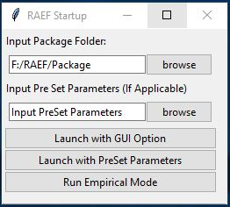

1. Example of the RAEF startup dialog

## Batch Run Option Vs. GUI Option

1. RAEF can be launched and run using two different options: 1) the GUI dialog mode or 2) the batch run mode (with pre-set parameters).
   1. GUI option, a user enters each RAEF run parameter individually into the GUI dialog during the GUI run using the visual tools in the GUI
   2. Batch run mode, users can input a pre-set parameters file into the system and go straight to the RAEF processing..
2. In addition to the two RAEF methods, RAEF GUI offers a tool to create an empirical model file to be used as the deposit simulation input in RAEF using the batch run option or the GUI option. This is further discussed in the Run Empirical Mode section.

## Launch RAEF Using the GUI Option (Without Pre-Set Parameters)

Running RAEF using the GUI option, requires users to enter the RAEF parameters.

1. Browse and select the RAEF package folder, “Package”, by clicking on “browse”.
   1. The RAEF package folder, is where the internal R scripts, input tables, and other needed files are located to run RAEF successfully.
2. Click on the button “Launch with GUI Option” to start the RAEF GUI dialog.
   1. A new GUI dialog opens, allowing users to select and enter a variety of parameters for the economic filter process.
3. Follow through the RAEF parameter input requests using the GUI dialog requests
4. Once all the parameters are entered, users can start the RAEF processing, as discussed below after the parameter input sections in the guide.

## Fill out the RAEF GUI Dialog

The RAEF dialog has 5 different sections requiring user input. These are 1) input files, 2) deposit information, 3) mining and mill methods, 4) days of operation (days per year), and 5) waste management options.

### Input Files

1. Browse and select the Deposit Grade-Tonnage Simulation input file for RAEF, by clicking on “browse” and selecting the CSV file.
   1. The CSV file may be a MapMark4GUI simulation result file, with the file name format of *RunID_05_Sim_EF.*
   2. Press “browse” right of the text box of “Econ Filter Simulation Input”.
   3. Find and select the desired MapMark4GUI simulation file.
2. Browse and select the working directory
   1. The working directory is the location hosting all output files
   2. Select a directory where files will be saved. If no directory exists, make one and select.
3. Submit working directory by clicking on “Set working directory”.
   1. The working directory address will be printed on the R console screen. Confirm the address was printed and correct. If not correct, redo the process.
4. Type in the run name inside the text box under “Run Name” to identify the output results.
   1. Multiple files using the run name are created.
   2. The run name should be less than 8 characters long.
5. Once all the above steps are completed and correct, click on “Continue - User Inputs”, the next GUI user input section opens, the deposit information.

See Figure 2 for an example of the Input Files section.

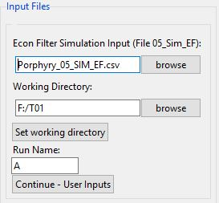

1. Example of the Input Files Section

### Deposit Information

1. Select the deposit type geometry classification appropriate for the deposit type under consideration. Select the geometry type in the drop-down menu.
   1. The appropriate mine method is chosen by the geometry classification and the depth to the top of the deposit (Smith, 1992, p. 6).
      1. Ore Body Massive/ Disseminated: Two mine types are options depending on depth to top of the deposit. For deposit depths less than 61 meters, Open Pit mines are selected. For deposits greater than or equal to 61 meters, Block Caving mines are selected.
      2. Flat-bedded/Stratiform: Two mine types are options depending on depth to top of the deposit. For deposit depths less than 61 meters, Open Pit mines are selected. For deposits greater than or equal to 61 meters, Room and Pillar mines are selected.
      3. Vein Deposit / Steep: Vertical Crater Retreat is the mine option.
2. Type in the tract area in the textbox.
   1. This area should be entered using square kilometers units with a value greater than 0.
3. Enter the depth profile information by 1) typing in the minimum and maximum deposit depth values and 2) select the number of depth intervals for user input from the drop-down menu.
   1. The minimum and maximum depth values are in meter units with values greater than or equal to 0.
   2. There can be 1 to 4 depth intervals selected for user input.
4. Press “Continue” once all the above parameters are entered correctly. Figure 3A shows a completed example of the above deposit information parameters.
5. A new dialog box with a series of depth intervals will open. Inside each depth interval dialog, enter the minimum, maximum, and the fraction of deposits that occur in this depth interval for each of the depth interval groups. Figure 3B shows an example of this depth interval dialog box.
   1. The interval minimum and maximum depths for each interval group should be greater than or equal to 0 in meter units.
   2. The interval fraction is the fraction of deposits to occur in this depth interval.
   3. The interval must be a decimal value between 0 and 1.
   4. The interval fractions for all intervals must sum to 1.
6. Click on “Continue” once the depth interval values are typed, the next section of the GUI will open, the mill information section.

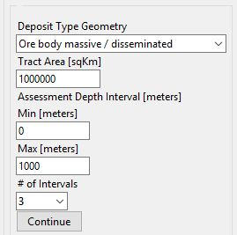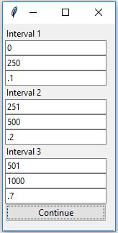

A..

B.

1. Deposit Information Section. A: Deposit information section where deposit geometry, tract area, and depth profile information is entered. B: The depth interval dialog box, where the interval depth range and fraction of deposits occurring in the intervals are entered.

### Mine and Mill Information

1. The mine type is identified by the program and displayed at the top of the next section of the GUI dialog.
2. The second line, shows the number of commodities detected in the Grade-Tonnage Simulation file.
3. Use the commodity information to select a mill option for the analysis by clicking the selected mill option radio button.
   1. The GUI lists default mill options.
      1. To select a mill option not included in the list of default mills, select “Customize Mill Options” as the default mill type selection.
         1. The customize mill option enables users to select a specific mill type for each individual commodity (limit is 2 different mill types for the commodity group).
            1. Under the custom mill dialog, a “None” option exists to eliminate a specific commodity from economic analysis resulting in no resources for this commodity being recovered.
      2. A user can forgo the mill cost in the RAEF calculation by selecting the “None” option in the default mills list.
         1. This will run the economic filter using just the mine costs assuming total recovery of all commodities.
4. Once the mill choice has been selected, press the “Continue” button. Figure 4A provides an example of the completed Mine and Mill information section of the RAEF GUI.
5. Custom Mill Option: a new dialog will open that offers a chance to customize the correspondence of mills to each commodity. In the new dialog a list of commodities that were detected from the MapMark4GUI simulation input are displayed with a drop-down box below each commodity abbreviation. Figure 4B shows an example of the Customize Mill Options dialog.
   1. For each commodity, select their corresponding mill option in the drop-down menus.
   2. Users can choose up to 2 mill methods, not including “None”
   3. Users can also correspond commodities to a user defined mill by clicking on “User Define.”
      1. This allows users associate specific commodities to a specific mill option in RAEF. This is done by clicking on “User Define” and clicking “Submit Mill Options.”
      2. A new dialog will pop up after completing all the rest of the parameter inputs and pressing “Confirm Data.” This where a user should enter the parameters for the user defined mill. The mill cost parameter equation coefficients include an equation constant and an exponent value for mill capacity. Users also need to define the metallurgical recovery rate of the commodity for the specific mill.
      3. For example, the capital cost equation for the 3- Product Flotation equation is 83600 * (Mill Capacity)0.703, where the constant is 83600 and the mill capacity exponent is 0.703.
   4. Users can also select “None” for specific commodities in the drop-down menu as the customize mill type.
      1. This will specify that a specific commodity is not recovered in the RAEF analysis.
6. Once all the mill option information has been entered, click on “Continue” to open the next set of GUI inputs: days of operation and waste management options.

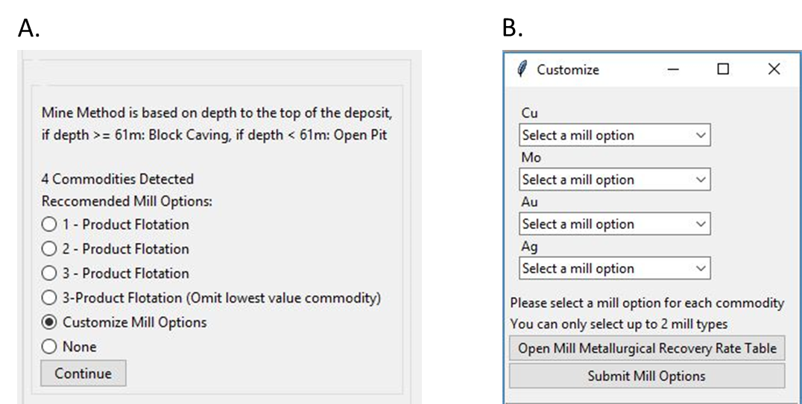

1. Mine and Mill Methods Section. A: Mine and mill section where the mine information is reported and the mill option is selected. B: The Customized Mill Options dialog box, where the custom mill options for each commodity can be selected.

### Days of Operation

1. Select the days of operation for the mine, by selecting its corresponding radio button. Figure 5 provides an example of the Days of operation section.
   1. Default options are full time operation at 350 days/year or restricted time at 260 days/year. Underground mines and mines in harsh climates are more likely to operate on a restricted schedule of 260 days/year (Smith, 1992).

### Waste Management

1. Select the waste management options by checking its corresponding GUI section box. Figure 5 provides an example of the Waste Management section of the RAEF GUI.
   1. Select whether there will be a 1) tailings pond and dam, and 2) tailings pond liner.
   2. The liner is an option only if the tailings pond and dam has been selected.
2. Click the “Continue” button to open the next set of GUI options. These options allow the user to change default RAEF parameters or to begin the RAEF analysis.

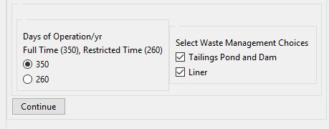

1. Example of the Days of Operation and Waste Management Sections

## Confirm Data

1. Click on the button “Confirm and check data”. Figure 7 is an example of the confirm button.
   1. This will check the data to confirm the commodities entered into the run have the model parameters including:
      1. Commodity Value
      2. Metallurgical Recovery Rate
      3. Corresponding mill parameters
   2. If the above parameters are not set for a specific commodity in the run, a popup window will ask the user to enter the needed information. Type in the values inside their text box. Figure 6 is an example of the popup dialogs asking for the missing information.
   3. If the data is confirmed and everything has been entered successfully, a message popup will open saying “All data has been checked and confirmed”. Click “OK” and continue to the next step.

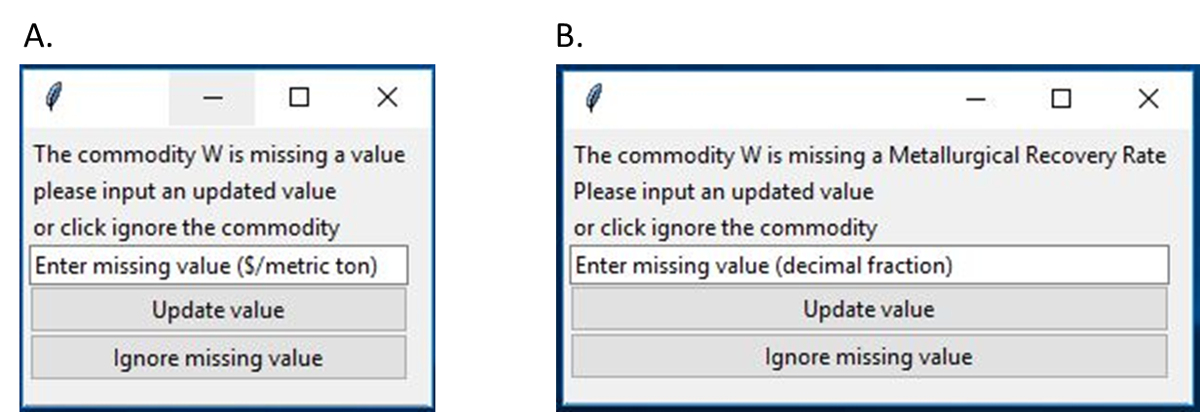

1. Example of the popup dialogs asking for a missing commodity (Tungsten) value (A) and metallurgical recovery rate (B).

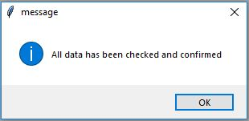

1. Example of confirmed data popup message

## Change Default Values

1. Once all the data has been confirmed, users can change the default values of the following items by clicking on their corresponding buttons: Figure 8A provides an example of the change defaults section.
   1. Metallurgical Recovery Rate for a specific commodity: “Change Default MRR”
      1. Select the corresponding commodity, and click “Continue.”
      2. Type in the new metallurgical recovery rate in the text box.
      3. Click “Submit” and “Exit” to confirm the changes and continue the process.
      4. Figure 8B provides an example of the Change Default Metallurgical Recovery Rate dialog.
   2. Marshall Swift Cost Index: “Change Default MSC (1.26)”
      1. 1.26 is the default value to adjust costs to a 2008 US Dollar basis.
      2. Type in the new value.
      3. Select “Confirm MSC Change”
   3. Investment Rate of Return: “Change Default Investment Rate of Return (0.15)”
      1. 0.15 (15%) is the default value for investment rate of return.
      2. Type in the new value
      3. Select “Confirm IRR Change”
   4. Operating Cost Inflation Factor: “Change Operating Cost Inflation Factor (1)”
      1. 1 is the default value for mining areas with operational settings like the western U.S. and most developed countries. High-cost mining areas with harsh climates or lacking infrastructure typically inflate operating costs by a factor of 1.4 or higher.
      2. Type in the new value
      3. Select “Confirm OCIF Change”
   5. Capital Cost Inflation Factor: “Change Cap Cost Inflation Factor (1)”
      1. 1 is the default value for mining areas with operational settings like the western U.S. and most developed countries. High-cost mining areas with harsh climates or lacking infrastructure typically inflate capital costs by a factor of 1.8 or higher.
      2. Type in the new value
      3. Select “Confirm CCIF Change”

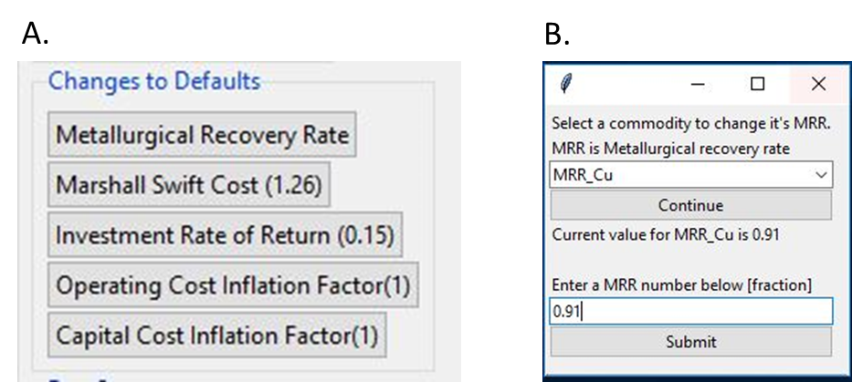

1. Changes to default values in RAEF section. A: Changes to defaults section of the RAEF GUI where a selection of default changes buttons are listed. B: An example of the Change Default Metallurgical Recovery Rate dialog.

## Run and Download RAEF Output

1. Press “Run RAEF Process” to start the RAEF analysis. Figure 9 provides an example of the Run RAEF button in the RAEF GUI.
   1. This will submit all parameters and start the economic filter analysis
   2. The results of the economic filter analysis of the simulated deposits will be written into a CSV file, using the name format of: *EF_02_Output_RunName.csv*
   3. Before running the economic filter analysis, the RAEF process will start with creating and downloading a table for the input run parameters, which can be modified and used if initially launching RAEF with preset parameters. This will be downloaded as a CSV format file, using the name format of: *EF_01_Parameters_RunName.csv.*

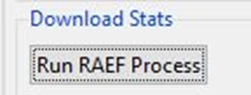

1. Run RAEF Process button

RAEF also performs statistical analysis on the economic filter results and creates four tables of aggregated resource results and two graphs showing estimated cutoff grade as a function of ore tonnage and deposit depth

1. The first statistical analysis is the aggregation of the resource results by the simulation run index.
   1. The results are aggregated by the number of deposits associated with each simulation index number, and provide aggregated results for the ore tonnage of the deposits, the tonnage of the in-ground contained resources, the tonnage of the recovered resources, and the net present value of the aggregated deposits by simulation index number.
   2. The results are saved to a file using the name format of *EF_03_Aggregated_Totals_RunName.csv*.
2. The process then creates a statistical summary using the aggregated data for the in-ground contained resources and the recovered resources This file is used as the summary of the resource assessment results.
   1. This provides statistics reporting means, maximums, standard deviations, percentiles, probability of zero, and probability of results greater than the mean for the aggregated in-ground and recovered resources for all of the simulation index results.
   2. The results are saved to a file using the name format of *EF_04_Contained_Stats_RunName.csv.*
3. The process then creates a statistical summary of resources by user-defined depth intervals
   1. This option reports an average (mean) of contained (in-ground) and recovered resources by commodity, reported as metric tons of commodity, aggregated by the user-defined depth intervals.
   2. The results are saved to a file using the name format of *EF_05_Depth_Stats_RunName.csv*.
4. The process then creates a statistical summary of resources by results using 10 depth levels
   1. This output is like the user-defined depth interval statistics, but the depth intervals are aggregated into 10 intervals by equal depth increments.
   2. Depth intervals are set as: (max depth – min depth / 10).
   3. The results are saved to a file using the name format of *EF_06_10Depth_Stats_RunName.csv* file
   4. This process will take some time. At the end of the waiting process the statistical file will be developed.
5. The process also creates a break-even ore value and break-even Copper Equivalent (CuEQ) grade table used to generate grade tonnage plots.
   1. The tables report estimated cut-off ore values and Copper Equivalent ore grades for each simulated deposit using deposit mine costs by deposit depth and recovered commodity values for the simulated deposits.
   2. The results are saved to a file using the name format of *“EF_07_BreakEvenTable_RunName.csv.”*
6. Using the above break-even table, the process creates the Ore Value / Metric Tons grade tonnage plot.
   1. This generates a graph of cut-off ore value (2008 $/t) by ore tonnage with depth interval contours.
   2. The plots are saved in .jpg, eps and tiff image formats.
   3. The plots are saved to files using the name format of: *RunName_CUEQ_MetricTons.jpg/eps/tiff*
7. In final the process creates a Generate the Cutoff Grade (CUEQ) / Metric Tons grade tonnage plot.
   1. This generates a graph of cut-off ore grade (CuEQ%) by ore tonnage with depth interval contours.
   2. The plots are saved in .jpg, eps and tiff image formats
   3. The plots are saved to files using the name format of: *RunName_CUEQ_MetricTons.jpg/eps/tiff*

Once the entire RAEF process is completed, the RAEF process will finalize the folder and delete unnecessary temporary files.

## Use the Pre-Set Parameters option

1. Inside the RAEF Startup dialog, browse and select the RAEF package folder, “Package”, by clicking on “browse”.
   1. The RAEF package folder, is where the internal R scripts, input tables, and other needed files are located to run RAEF successfully.
2. Browse and select a Pre-Set Parameters input file by clicking on “browse”.
   1. A batch input file (Pre-Set Parameters file) listing the user specified run parameters will need to be created first.
   2. The parameters are the same as those specified using the GUI option.
   3. The batch file should have a format identical to the RAEF parameters output file from a previous RAEF run. The RAEF parameters file has a name using this format: *RunID_EF_01_InputParameters.csv*.
   4. A previous run parameters file can be used as the batch input file, if output names and addresses are updated with new information.
      1. Previous run files could be used to duplicate an earlier economic filter run, or its parameters can be edited to derive a new RAEF analysis.
      2. The edited input parameters file needs to preserve the format and information order of the previous parameters file.
   5. Table 1 provides a list of available RAEF parameter options. Parameter options need to be entered using the same case and name as in Table 1.
3. Click on the button “Launch with PreSet Parameters” to input the parameters file and launch the RAEF GUI dialog.
4. This will start the RAEF process using the input parameters.
5. A new dialog will open up during the batch run process and show the progress in the RAEF process. In addition it prints out on the dialog the start and completion time. Figure 10, is an example of the new batch run status dialog.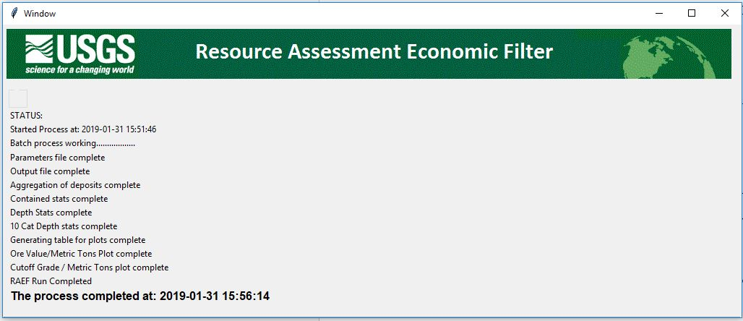
6. Example of the batch run status dialog.
7. Pre Set Parameters Options

|  |  |
| --- | --- |
| **Number of Depth Intervals** | **Mill Type (Default)** |
| 1 | 1 – Product Flotation |
| 2 | 2 – Product Flotation |
| 3 | 3 – Product Flotation |
| 4 | 3 – Product Flotation (Omit lowest value commodity) |
|  | |
| **Deposit Type** | **Days of Operation** |
| Flat-bedded/stratiform | 350 |
| Ore body massive / disseminated | 260 |
| Vein deposit / steep |  |
|  | |
| **Tailings pond?** | **Liner?** |
| Tailings Pond and Dam | 1 |
|  | 0 |

## Run Empirical Mode

1. Obtain or create a MapMark4GUI simulation file that will guide the empirical mode process.
   1. A grade-tonnage deposit model file is used with a MapMark4GUI file to create the input file used to run the Empirical Mode option.
   2. The grade-tonnage file needs to have the same number of commodities as the Mapmark4GUI simulation file used in the option.
   3. A previous MapMark4GUI simulation file, *RunName_05_SIM_EF.csv,* with the needed parameterscan be used as input.
2. Inside the RAEF startup dialog, browse and select the RAEF package folder by pressing “browse.”
3. Press “Run Empirical Mode” on the RAEF startup dialog.
4. An Empirical Option dialog box will open. Browse and select the MapMark4 simulation file from step 1, by pressing “browse.” Figure 12 provides an example of the Empirical Option dialog.
5. Browse and select the Grade Tonnage Model that will be used to generate the empirical simulation file.
   1. The resulting empirical simulation file will have a similar format to the MapMark4GUI simulation file.
6. Browse and select the output directory where the new empirical file should be written.
7. Type a name for the empirical run inside the text box.
8. Click on “Create Empirical Model” to start the process of creating the empirical simulation file by randomly sampling the grade-tonnage model data.
   1. This creates a new simulation model using the grade-tonnage model data. The file is then outputted in the specified output file directory and using the new test name.
   2. The empirical file will be named in the format of: *TestName _EmpTable.csv*
9. Run the RAEF process normally as listed above, but use the empirical model file, instead of the MapMark4GUI simulation file, as the economic simulation file input.

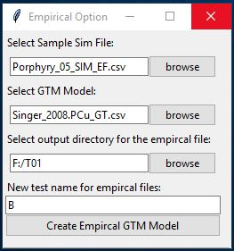

1. Example of the Empirical Option dialog

RAEF Tutorial Exercises

Included in the package is a tutorial folder with example files to explore RAEF operations, options, and output files. The folder includes 5 tutorial exercises that use two deposit model examples: 1) Porphyry Cu deposits and 2) Conduit Ni deposits. Each deposit can be run using two options: 1) a normal Grade Tonnage model with no missing grade data, or 2) an Empirical Run model allowing missing grade values.

An addition tutorial exercise uses a Pre-Set Parameters file to run the RAEF analysis on the Porphyry Cu deposit model. The folder includes the sample input files and output files to check the run’s results.

### Porphyry Copper Deposits Exercise 1A: Regular Non-Missing Grade Values Run

The input files for this tutorial are found in the TUTORIAL_Pkg\Inputs\T1\A folder. Example output files for this run are found in the TUTORIAL_Pkg\Outputs\T1\A folder.

1. Run the RunRAEF R script. Once the RAEF startup dialog is launched, browse and select the RAEF package folder.
2. Once the package has been set, click on the “Launch with GUI Option” button, to start entering the RAEF parameters. When the startup RAEF dialog opens up, browse and select for the economic filter simulation file. This will be the MapMark4GUI results simulation file, *Porphyry_05_SIM_EF.csv*.
3. Browse and select the working directory and enter the Run Name. Once these tasks are done, users can continue by pressing “Continue- User Inputs”.
4. Enter the deposit parameters. To obtain similar results as in the Tutorial Outputs folder, use the following parameters: Figures 13 A and B provide examples of the completed RARF dialogs using the tutorial exercise parameters, A: RAEF GUI and B: Depth interval dialog.

* Deposit Type Geometry: Ore body massive / disseminated
* Tract Area: 1000000
* Assessment Depth Interval
* Min: 0
* Max: 1000
* # of intervals: 3
* Interval 1:
* Min: 0
* Max: 250
* Fraction: .2
* Interval 2:
* Min: 251
* Max: 500
* Fraction: .2
* Interval 3:
* Min: 501
* Max: 1000
* Fraction: .6

1. Once all the deposit parameters are entered, click on the “Continue” button on the depth interval parameter dialog to input the mine and mill parameters. To obtain similar results as in the tutorial output folder, use the following mill option: 3- Product Flotation.
2. Once all the mine and mill parameters are entered, users can click on “Continue” to continue to input the operation and waste management choices. To correspond with the tutorial output folder, the following choices were used:

* Days of operation: 350
* Waste Management: Tailings pond and Liner

1. Once all of the above parameters are entered, click on “Continue” then “Confirm and check data”, and remaining run buttons.

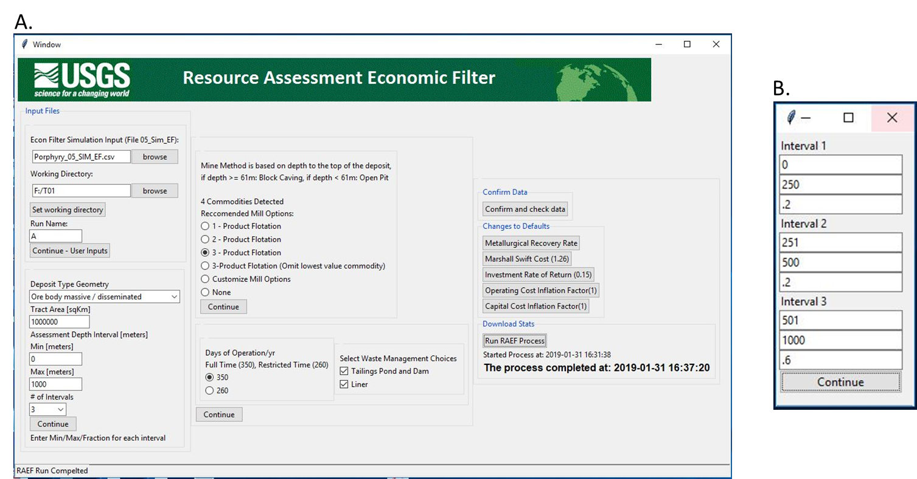

1. Example of the completed Exercise 1A dialogs using the tutorial exercise parameters. A: RAEF GUI, B: Depth Interval dialog box.

### Porphyry Copper Deposits Exercise 1B: Empirical Missing Grade Values Run

The input files for this process can be found in the TUTORIAL_Pkg\Inputs\T1\B folder. The output files for this run can be found in the TUTORIAL_Pkg\Outputs\T1\B folder.

In this tutorial, follow steps as in the first exercise, but first create a new empirical simulation model to replace the simulated deposits in the original MapMark4GUI file with random samples from the grade-tonnage model for the deposit type. To do this click on “Run Empirical Mode” in the startup dialog. In this dialog, select a sample simulation file, the Grade Tonnage Model, the working directory, and the run name. The following parameters can be entered to get a file similar to the output folder. Figure 14 A, B, and C provide examples of the completed RARF dialogs using the tutorial exercise parameters, A: Empirical Option dialog, B: RAEF GUI, and C: Depth Interval dialog.

* Sample Sim File: The MapMark4GUI simulation result file that was used in the first exercise, Porphyry_05_SIM_EF.csv.
* GTM Model: The grade tonnage model with the missing values, Singer_2008.PCu_GT.csv

Once all the parameters are entered, click on “Create Empirical Model.” This will create the new simulation file to be used for the RAEF run, Porpyry_EmpTable.csv.

Start the RAEF process using the RAEF startup dialog by clicking on “Launch with GUI Option.” Follow the rest of the steps from the Porphyry Copper Deposits Exercise 1A exercise. Select the empirical model file, Porpyry_EmpTable.csv, as the economic simulation input file. To obtain a similar result as in the tutorial output folder, users should enter the same parameters as the Porphyry Copper Deposits Exercise 1A exercise.

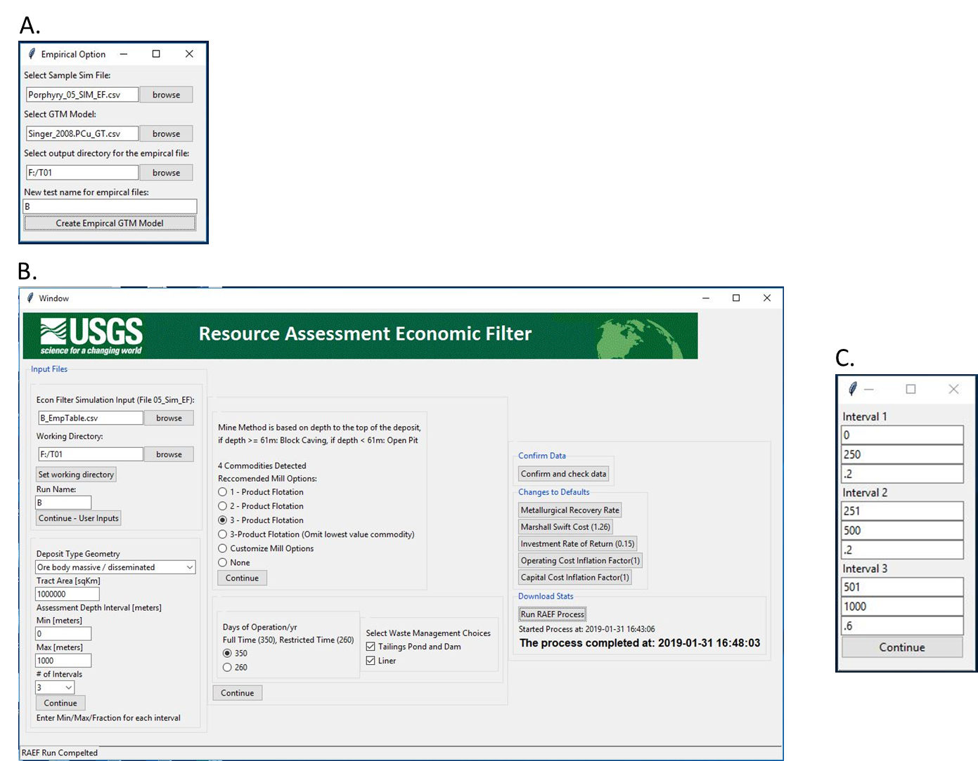

1. Example of the completed Exercise 1B dialogs using the tutorial exercise parameters, A: Empirical Option dialog. B: RAEF GUI. C: Depth interval dialog box.

### Porphyry Copper Deposits Exercise 1C: Using a Pre-Set Parameters File

The input files for this process can be found in the TUTORIAL_Pkg\Inputs\T1\C folder. The output files for this run can be found in the TUTORIAL_Pkg\Outputs\T1\C folder.

In this run, users will follow steps similar to the Porphyry Copper Deposits Exercise 1A exercise, but will enter the run parameters through a file instead of using the dialog.

To run RAEF using a Pre-Set Parameters file, browse to the tutorial input files and select the Pre-Set Parameters file in the startup dialog. The tutorial Pre-Set Parameters file is named: PreSetFile.csv. This file is similar in parameters from the first exercise. Once the pre-set file has been selected, click on “Launch with PreSet Parameters.” This will enter the parameters and start the RAEF process and launch a new dialog with the process status of the run.. This exercise should get similar results from the first exercise. Figure 15 A and B provide examples of the completed RAEF dialogs using the tutorial exercise parameters, A: RAEF Startup dialog and B: RAEF Status dialog using the PreSet Parameters option.

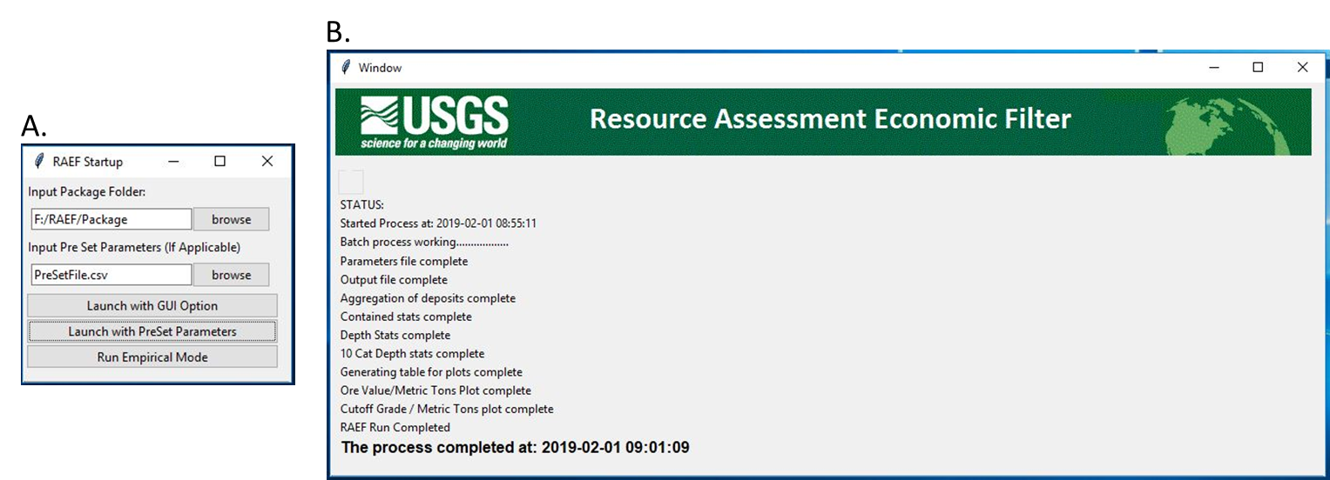

1. Example of the completed Exercise 1C dialogs using the tutorial exercise parameters, A: RAEF Startup dialog. B: RAEF Status Dialog using the PreSet Parameters option.

### Conduit Deposits Exercise 2A: Regular Non-Missing Grade Values Run

The input files for this process can be found in the TUTORIAL_Pkg\Inputs\T2\A folder. The output files for this run can be found in the TUTORIAL_Pkg\Outputs\T2\A folder.

This tutorial is similar to tutorial Porphyry Copper Deposits Exercise 1A, but uses a new deposit model dataset, MapMark4GUI simulation result, and new commodities. This deposit model commodities include: Copper (Cu), Nickel (Ni), Platinum (Pt), and Palladium (Pd).

As in above, users can start the RAEF process, by clicking on “Launch with GUI option.” Figures 16 A and B provide examples of the completed RARF dialogs using the tutorial exercise parameters, A: RAEF GUI and B: Depth interval dialog. Follow the rest of the steps from the Porphyry Copper Deposits Exercise 1A exercise, using these new RAEF parameters:

* Economic Simulation File: *Conduit_05_SIM_EF.csv*
* Deposit Type Geometry: Vein deposit / steep
* Tract Area: 1000000
* Assessment Depth Interval
* Min: 0
* Max: 1000
* # of intervals: 4
* Interval 1:
* Min: 0
* Max: 200
* Fraction: .3
* Interval 2:
* Min: 201
* Max: 400
* Fraction: .2
* Interval 3:
* Min: 401
* Max: 500
* Fraction: .2
* Interval 4:
* Min: 501
* Max: 1000
* Fraction: .3
* Mill Options: 3- Product Flotation
* Days of operation: 350
* Waste Management: None

Once all the parameters are entered, the user can click on “Confirm and check data.” Once these data are entered and confirmed, users can complete the run steps.

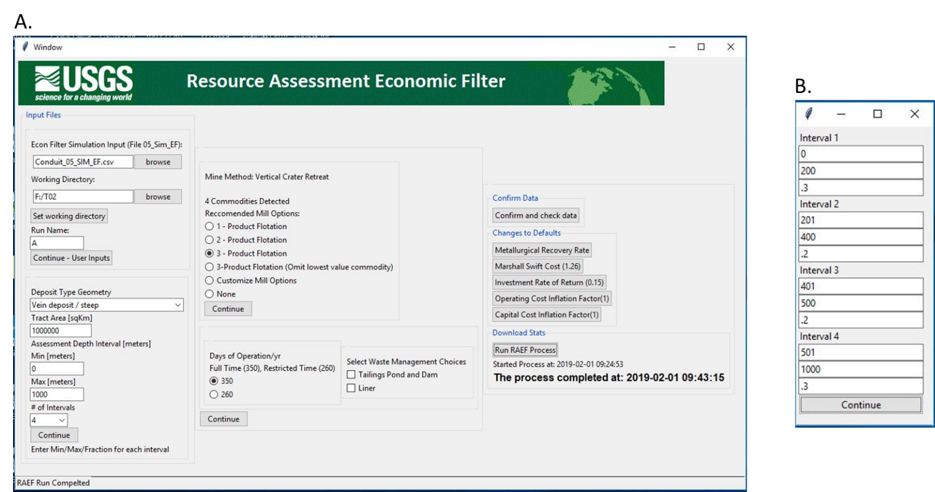

1. Example of the completed Exercise 2A dialogs using the tutorial exercise parameters, A: RAEF GUI. B: Depth Interval dialog box.

### Conduit Deposits Exercise 2B: Empirical Missing Grade Values Run

The input files for this process can be found in the TUTORIAL_Pkg\Inputs\T2\B folder. The output files for this run can be found in the TUTORIAL_Pkg\Outputs\T2\B folder.

In this tutorial, follow steps similar to the Conduit Deposits Exercise 2A exercise. Create a new empirical simulation model for Conduit Deposits using the procedure outlined in Porphyry Copper Deposits Exercise 1B.

The following parameters can be entered to get a file similar to the results in the Tutorial 2B output folder:

* Sample Sim File: The MapMark4GUI simulation result file that was used in the third exercise, *Conduit_05_SIM_EF.csv*.
* GTM Model: The grade tonnage model with the missing values, *Conduit_MissingValues_GTM.csv*

Once all the parameters are entered, press “Create Empirical Model.” This will create a new simulation file that can be used for the RAEF program run, *B_EmpTable.csv*.

Click on “Launch with GUI option.” in the RAEF startup Dialog to start the RAEF process. Follow the rest of the steps from the Conduit Deposits Exercise 2A exercise. Select the new empirical model file that was created, named *B_EmpTable.csv,* to enter as the simulation file input. To obtain a similar result as to the output folder, enter the same parameters as the Conduit Deposits Exercise 2A exercise. Figure 17 A and B provide examples of the completed RARF dialogs using the tutorial exercise parameters, A: Empirical Option dialog and B: RAEF GUI.

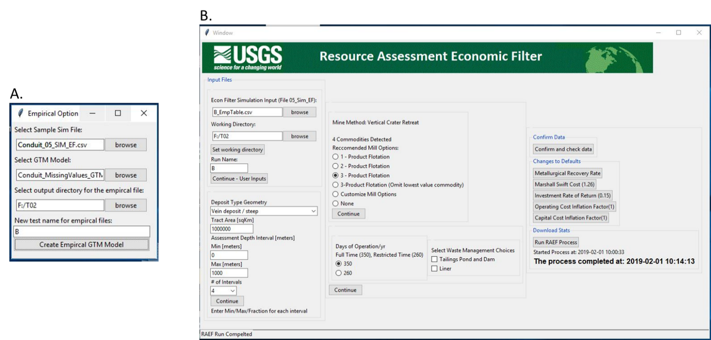

1. Example of the completed Exercise 2B dialogs using the tutorial exercise parameters, A: Empirical Option dialog and B: RAEF GUI.

## References Cited

Smith, R. C.,1992, PREVAL: Prefeasibility software program for evaluating mineral properties, V. 1.01, U.S. Bureau of Mines Information Circular 9307, 35p.